Task No 01:

Input:

<html>

    <P> There are six levels of heading in HTML. The lower the number, the larger the header will be. Thus H1 is the largest header, and H6 is the smallest</P>

<h1> Heading 1</h1>

<h2> Heading 2</h2>

<h3> Heading 3</h3>

<h4> Heading 4</h4>

<h5> Heading 5</h5>

<h6> Heading 6</h6>

</html>

Output:

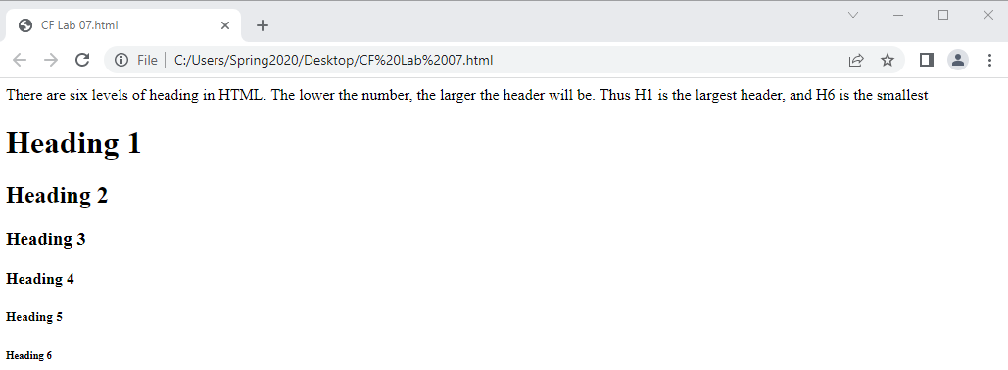

Task No 02:

Input:

<html>

<h4><center>THE CENTER TAG</center></h4>

<P><CENTER>My Name is Abdullah sadiq.</CENTER></P>

</html>

Output:

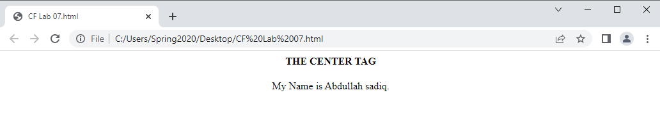

Task No 03:

Input:

<html>

<P style="color:black:50px ;All"><CENTER> All of My social Media Handles </CENTER></P>

<p><center> Click on this Link: <a href="linktr.ee/iabdullahsadiq">LinkTree</a></center></p>

</html>

Output:

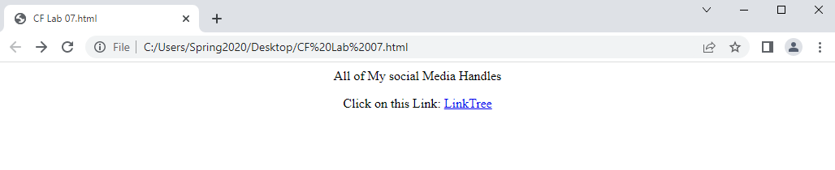

Task No 04:

1. Input:

<html>

<table border="1">

    <tr>

        <td>Num 1</td>

        <td rowspan= "2" bgcolor="green"> Num 2</td>

        <td>Num 3</td>

    </tr>

    <tr>

        <td> Num 4</td>

        <td> Num 5</td>

    </tr>

</table>

</html>

1. Output:

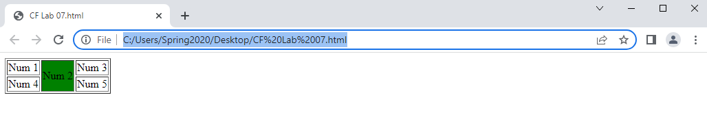

1. Input:
2. <html>
3. <table border="1">
4. <tr>
5. <td rowspan= "2" bgcolor="green">Num 1</td>
6. <td> Num 2</td>
7. <td>Num 3</td>
8. <td> Num 4</td>
9. </tr>
10. <tr>
11. <td> Num 5</td>
12. <td> Num 6</td>
13. <td> Num 7</td>
14. </tr>
15. </table>
16. </html>
17. Output:

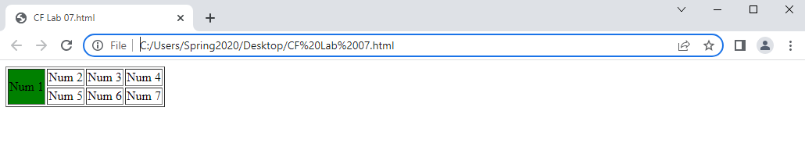

Task No 05:

Input:

Output:

Task No 06:

Input:

Output: